

PROGRAM BOOK

COMMUNITY SERVICE PROJECT

AP STATE COUNCIL OF HIGHER EDUCATION

GOVERNMENT OF ANDHRA PRADESH

COMPUTER SCIENCE & ENGINEERING

# COMMUNITY SERVICE PROJECT REPORT

on

# HEALTH GUARDIANS PROMOTING HYGIENE FOR ALL AND A PATH TO VAITALITY

by

P.SNEHA 22JN1A05B5

Under guidance of

Mr. B.RAJASHEKAR REDDY,M.Tech,

Assistant Professor, Department of



# SREE VENKATESWARA COLLEGE OF ENGINEERING

(Approved by AICTE, New Delhi and Affiliated to Jawaharlal Nehru Technological University – Anantapur) GOLDEN NAGAR, NH5 BYPASS ROAD, NORTH RAJUPALEM, KODAVALURU (V&M), SPSR NELLORE

An ISO 9000:2015 Certified Institution

# PROGRAM BOOK

**FOR**

# COMMUNITY SERVICE PROJECT

Name of the Student :

P.SNEHA

Name of the College : SREE VENKATESWARA COLLEGE OF ENGINEERING

Registration Number :

22JN1A05B5

Period of CSP :

8 WEEKS

From 13-05-2024 **To**

06-07-2024

### Title : HEALTH GAURDIANS PROMOTING HYGIENE FOR ALL AND A PATH TO VAITALITY

Address of the Community : S.P.S.R NELLORE, A.P

# COMMUNITY SERVICE PROJECT REPORT

*(Submitted in accordance with the requirement for the degree of B.Tech)*

Name of the college : **SREE VENKATESWARA COLLEGE OF ENGINEERING**

Department : **COMPUTER SCIENCE & ENGINEERING**

Name of the faculty :

##### Mr. B.RAJASHEKAR REDDY

- ASSISTANT PROFESSOR DEPARTMENT OF CSE

|  |  |
| --- | --- |
| Title | **:** HEALTH GUA  -LITY . |
| Duration of CSP | : **FROM** |
| Name of the student | : **P.SNEHA** |
| Course of study | : **B. Tech** |
| Year of study | : **3RD Year** |
| Registration number | : **22JN1A05B** |
| Date of submission | : |

RDIANS PROMOTING HYGIENE FOR ALL AND A PATH TO VAITA

13-05-2024

##### 5

**To** 06-07-2024

# STUDENT’s DECLARATION

**P.SNEHA** a student of III year B.tech, Reg.22JN1A05B5 of the Department of CSE.I do here by declare that I have comple

-ted the mandatory community service project from 13-05-2024 to 06-07-2024.

do hereby declare that I have completed the mandatory community serviceproject from13-05-2024

In the topic of HEALTH GUARDIANS PROMOTING HYGIENE FOR ALL AND A PATH TO VAITALITY

under the faculty guide Mr.B. RAJASHEKAR REDDY,professor ,Department of CSE in

SREE VENKATESWARA COLLAGE OF ENGINEERING.

.

(SIGNATURE)

Endorsements

Faculty Guide

Head of Department

Principal

# Certificate from Official of the Community

This is to certify

**PACHARI SNEHA**

Reg. No

#### 22JN1A05B5

**SREE VENKATESWARA COLLEGE OF ENGINEERING** underwent Community Service Project in

#### HEALTH GUARDIANS PROMOTING HYGIENE FOR ALL AND A PATH TO VAITALITY

from13-05-2024 to 06-07-2024.

The overall performance of the Community Service Volunteer during his community service is found to be (Satisfactory/Good).

Authorized signature with Date and Seal

**ACKNOWLEDGEMENTS**

I would like to take this opportunity to acknowledge the everyone who has helped us in eve

-ry stage of this project.I express my deep sense of gratitude to all those who have been instrumental in preparation of th

e project .

Assistant professor,Department of CSE of her significant suggestions and my most sincere and grateful

acknowledge to Dr.GUNA SEKHAR, chairman who took keen interest and encouraged us in every effort throught this course.

I own my gratitude to Dr.C.PRAKASA RAO,principal, Sree Venkateswara College of Engineering ,nellore .

DR.T.SWARNALATHA,Head of the Department,Computer science and engineering for giving us the opportunity to do this commu

-nity service project on the topic HEALTH GUARDIANS PROMOTING HYGIENE FOR ALL AND A PATH TO VAITALIT I take this opportunity to express my sincere deep sense of gratitude to our guide ,MR.B.RAJASHEK

I would like to thank Community service project coordinator MRS.SK.FARHANA,assisstant Professor,Department of

CSE for her persisting encouragement and keen interest in discussion have benefited us to an extent that cannot be spanned by words.

Finally, I am thankful to the technical and non-technical staff of Sree Venkateswara College of Enginnering,Nellore and parents,friends and all my well-wishers for their assistance in finishing the Community Service project successfully.

##### P.SNEHA

**22JN1A05B5**

### CHAPTER-1 :: EXECUTIVE SUMMARY

**Introduction:**

In today's fast-paced world, maintaining good health and hygiene is paramount for individuals and communities alike. Health and hygiene are interconnected concepts that encompass physical, mental, and social well-being. This executive summary provides an overview of the importance of health and hygiene, outlining their significance in promoting overall well-being and preventing diseases.

1. Importance of Health:

Good health is a fundamental right and a key indicator of a thriving society. It not only enhances the quality of life but also contributes to economic productivity. Healthy individuals are more productive, leading to increased work efficiency and economic growth. Health is not merely the absence of diseases but a holistic state of physical, mental, and social well-being.

1. Significance of Hygiene:

Hygiene practices are essential to prevent the spread of diseases and maintain health. Personal hygiene, such as regular handwashing and oral care, is crucial in preventing infections. Public hygiene, including clean water supply and sanitation facilities, plays a pivotal role in reducing the prevalence of water-borne diseases. Proper hygiene also extends to food safety, ensuring that the food we consume is free from contaminants.

1. Impact on Communities:

Communities with access to healthcare services and education about hygiene practices experience lower mortality rates and improved life expectancy. Additionally, promoting hygiene in schools enhances the well-being of children, reducing absenteeism due to illnesses. Moreover, communities with adequate sanitation and clean water sources are more resilient to disease outbreaks, leading to improved public health outcomes.

1. Challenges and Solutions:

Despite the importance of health and hygiene, many challenges persist. Limited

access to healthcare services, inadequate sanitation facilities, and lack of awareness about proper hygiene practices hinder progress. Addressing these challenges requires collaborative efforts from governments, non-governmental organizations, and communities. Investments in healthcare infrastructure, education, and public awareness campaigns are essential to overcoming these obstacles.

1. Conclusion:

In conclusion, prioritizing health and hygiene is crucial for individual well-being and societal development. By promoting awareness, investing in healthcare infrastructure, and ensuring access to clean water and sanitation facilities, we can create healthier communities and a better future for generations to come. Emphasizing the significance of health and hygiene is not just a necessity but a moral imperative that can transform lives and uplift societies.

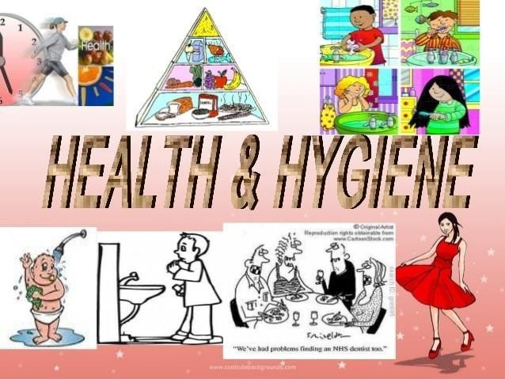

### CHAPTER-2 :: OVERVIEW OF COMMUNITY

As part of our Community Service, I have selected NELLORE as my serving community and visited the fields in the places nearby. I visited around all areas nearby NELLORE, Each area is located around 5-6 KM approximately from the headquarters of mandal.

NELLORE is a TOWN in the Nellore district of the Indian state of Andhra Pradesh. It is also the headquarters of the NELLORE Mandal and Assembly Constituency. It is located in NELLORE mandal of Nellore revenue division. It forms a part of Nellore Urban Development Authority. The poet "Thikkanna" was born in this place. NELLORE is located at 14.5001°N 79.9859°E and at an altitude of 19 m (62 ft).

The TOWN is spread over an area of 6.28 km2 (2.42 sqm). Penna River is the major river flows in the proximity of the TOWN.

As of the 2011 census, NELLORE had a population of 32,082. The sex ratio was 988 females per 1000 males. The literacy rate was 73.37%.

NELLORE is a major agricultural market in the Nellore district. The main crops grown in the TOWN are paddy, cotton, and groundnut. There are also several industries in NELLORE, including textile mills, rice mills, and sugar mills.

NELLORE is well-connected by road and rail. The National Highway 5 passes through the TOWN. NELLORE railway station is on the Chennai-Howrah main line. NELLORE is a popular tourist destination.

# CHAPTER-3 :: COMMUNITY SERVICE PART

✵ The activities I did during the project are:

* Interacting with people
* Asking them questions to suggest about health and hygiene
* Getting questions from them
* Giving information on self hygiene
* Giving advice to managements
* Guidelines to improve health and hygiene

✵ The outcomes we learned are:

* I learnt about interaction with people
* I got to know different methods in health measures
* Leant about how to keep our body healthy

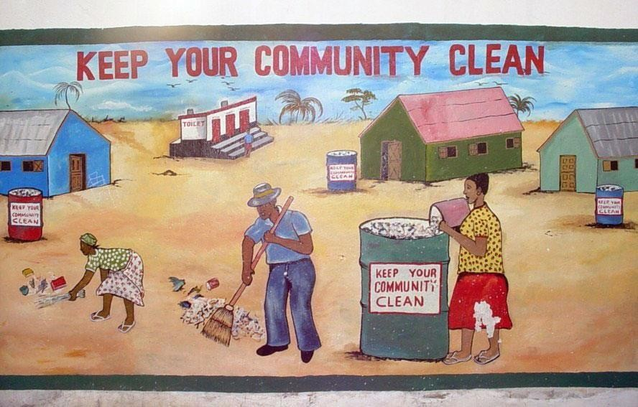

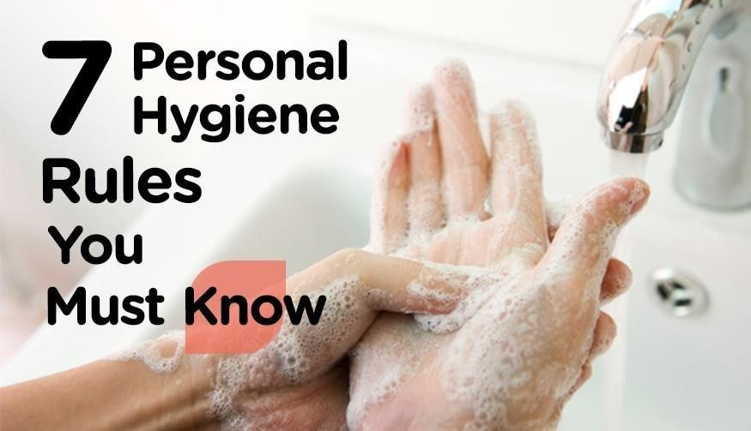

**Types of personal hygiene**

There are many types of personal hygiene.

The following list is a good starting point for someone looking to build a personal hygiene routine:

**Dental**

Dental hygiene involves more than just having white teeth. A good dental hygiene routine can help prevent issues such as [gum disease](https://www.medicalnewstoday.com/articles/241721) and cavities. It can also prevent [bad breath.](https://www.medicalnewstoday.com/articles/166636)

**Body**

Several million sweat glands cover the human body. When bacteria break down sweat, the process creates a smell or body odour.

Washing the body will help prevent skin irritation, as well as removing the bacteria that cause [body odour.](https://www.medicalnewstoday.com/articles/173478) Washing the hair removes oil and keeps a person looking clean and fresh.

**Hand washing**

Regular hand washing is one of the best ways to avoid spreading communicable diseases.

The [Centres for Disease Control and Prevention (CDC)Trusted Source](https://www.cdc.gov/healthywater/hygiene/hand/handwashing.html) recommend washing the hands at certain times:

* before, during, and after preparing food
* before eating food
* before and after looking after anyone who is vomiting or has diarrhea.
* before and after treating a cut or wound
* after going to the bathroom
* after changing diapers or cleaning up a child who has used the toilet
* after blowing the nose, coughing, or sneezing
* after touching garbage or dirty surfaces or objects after handling pets or pet-related items, such as food

**Nails**

Fingernails may harbour dirt and germs, contributing to the spread of bacteria. It is easier for dirt and germs to collect under longer nails, so keeping them short can help reduce the risk of spreading

infections.

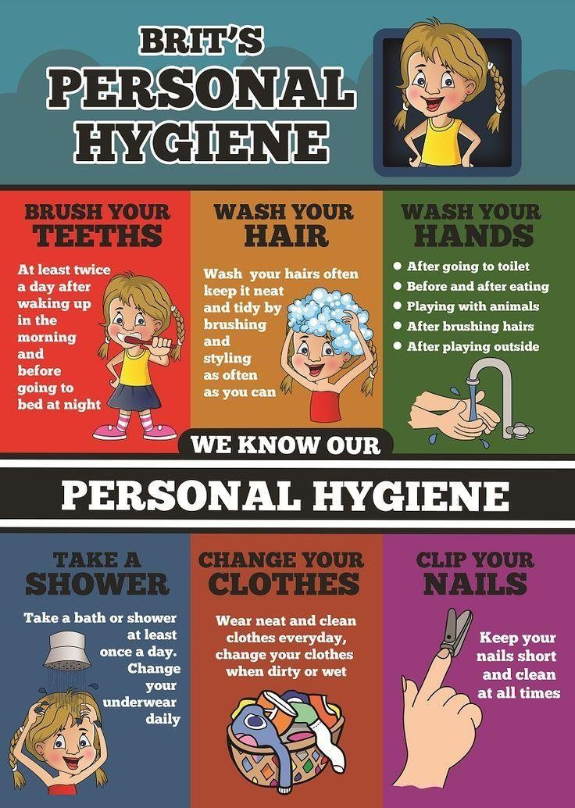



During this community service I observed some of the problems faced by people. The problems I noted are:

* [Athlete’s Foot (tinea pedis)](https://www.cdc.gov/fungal/diseases/ringworm/index.html)
* [Body Lice](https://www.cdc.gov/parasites/lice/body/index.html)
* [Chronic Diarrhea](https://www.cdc.gov/ncezid/dfwed/diseases/brainerd-diarrhea/)
* [Dental Caries (Tooth Decay)](https://www.cdc.gov/OralHealth/index.html)
* [Head Lice](https://www.cdc.gov/parasites/lice/head/index.html)
* [Hot Tub Rash (*Pseudomonas* Dermatitis/Folliculitis)](https://www.cdc.gov/healthywater/swimming/swimmers/rwi/rashes.html)
* [Lymphatic Filariasis](https://www.cdc.gov/parasites/lymphaticfilariasis/)
* [Pinworms](https://www.cdc.gov/parasites/pinworm/index.html)
* [Pubic Lice (“Crabs”)](https://www.cdc.gov/parasites/lice/pubic/index.html)
* [Scabies](https://www.cdc.gov/parasites/scabies/)
* [Swimmer’s Ear (otitis externa)](https://www.cdc.gov/healthywater/swimming/swimmers/rwi/ear-infections.html)
* [Trachoma](https://www.cdc.gov/hygiene/disease/trachoma.html)
* [Recreational Water Illnesses (RWIs)](https://www.cdc.gov/healthywater/swimming/swimmers/rwi.html)
* [*Acanthamoeba* keratitis (AK)](https://www.cdc.gov/parasites/acanthamoeba/gen_info/acanthamoeba_keratitis.html)
* [Ringworm (Tinea)](https://www.cdc.gov/fungal/diseases/ringworm/index.html)

# ACTIVITY LOG FOR FIRST WEEK

|  |  |  |  |
| --- | --- | --- | --- |
| **DAY & DATE** | **BRIEF DESCRIPTION** | **LEARNING OUTCOME** | **PERSON INCHARGE**  **SIGNATURE** |
| **DAY-1** | I selected an area to make  the project on importance of “HEALTH AND HYGIENE” | I have Visited my area  in chamadala,nellore dt. |  |
| **DAY-2** | I gathered the information about Health and Hygiene. | I got the information about their effect in environment. |  |
| **DAY-3** | I met a volunteer of my area and made a detailed explanation of my project. | I went to meet the volunteer and took permission to conduct the survey. |  |
| **DAY-4** | I discussed about Health and Hygiene to the volunteer | I met another volunteer and explained the effect of hygiene on people. |  |
| **DAY-5** | Conducted the awareness activity on Health and Hygiene. | People should realise about how it damages their  health. |  |

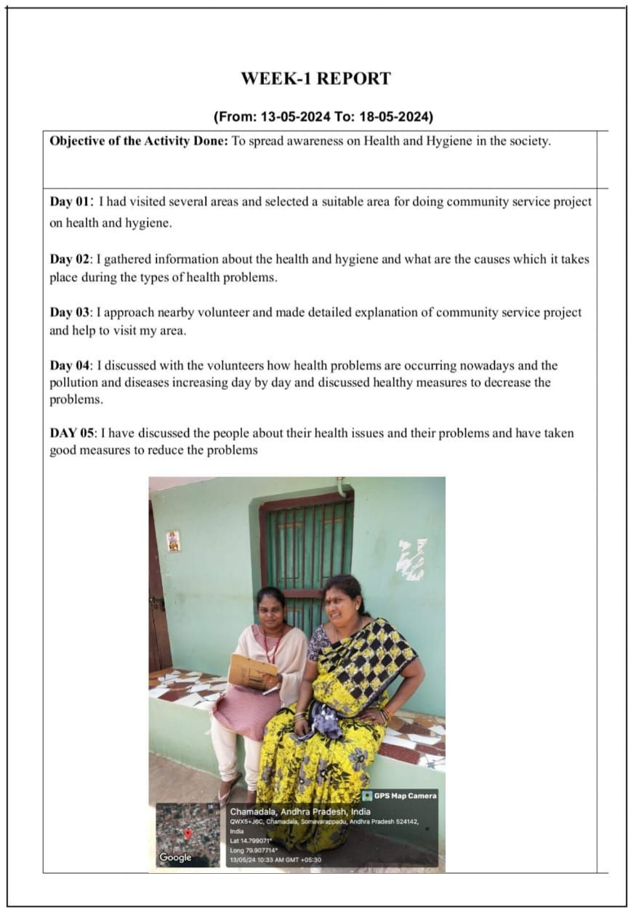

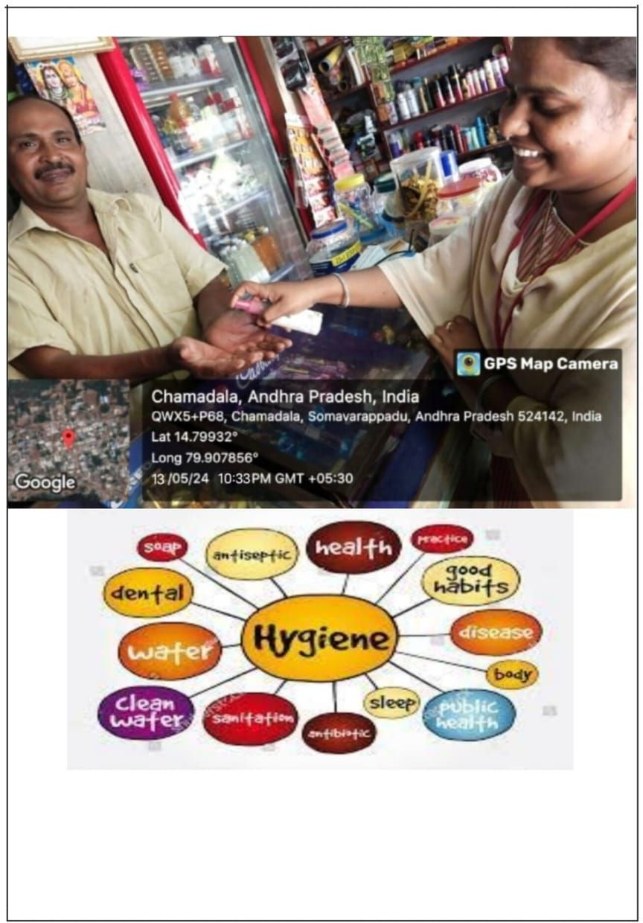

**ACTIVITY LOG FOR SECOND WEEK**

|  |  |  |  |
| --- | --- | --- | --- |
| **DAY & DATE** | **BRIEF DESCRIPTION** | **LEARNING OUTCOME** | **PERSON INCHARGE**  **SIGNATURE** |
| **DAY-1** | Started the second week with the awareness program and visited some area and  examined the area. | I started the awareness program and got the good response from the people. |  |
| **DAY-2** | On the next day I started the program on the needs of health and hygiene. | By the awareness activity the people got to know the proper needs of the health and hygiene. |  |
| **DAY-3** | The next day I started to visit the nearby hospital to collect the healthy tips on health and hygiene. | The doctor suggested me how to improve the health by taking the good measures. |  |
| **DAY-4** | On the next day I visited some schools and made an awareness program on health and hygiene. | The children understood the importance of health and hygiene. |  |
| **DAY-5** | On the last day I ended these awareness program by spreading the healthy  measures to all the people. | As the people and the students have clearly got to know that their health abnormal due to the unproper maintenance of their body. |  |

## WEEK-2 REPORT

**(From: 20-05-2024 To: 25-05-2024)**

|  |
| --- |
| **Objective of the Activity Done:** To spread awareness on Health and Hygiene in the society. |
| **Day 01: S**tarted the second week with the awareness program and first visited some areas and examine the area. After examination of the area. I have got to know that the health is also affected due to bad environmental condition. If that environmental conditions are set to good and clean then there will be good health and hygienic society.  **Day 02**: On the next day I started to collect the information about the needs of health and hygiene. In this process I have collected some of the basic needs to keep our good and proper health.  Personal hygiene includes:   * Cleaning your body every day. * Washing your hands with soap after going to the toilet. * Brushing your teeth twice a day. * Covering your mouth and nose with a tissue (or your sleeve) when sneezing or coughing. * Washing your hands after handling pets and other animals.   **Day 03**: On the third day i also visited the nearby by clinic to collect more information about the importance of health and hygiene. Here are some important points.  1.Sanitation Hygiene. 2.Hand Hygiene.   1. Surface Hygiene. 2. Hygiene for Healthcare Workers.   **Day 04:** On the fourth day I started to visit some shops to make an awareness on health and hygiene. In that process I explained them about the personal hygiene.  **Day 05:** On the fifth day i gathered some children and make them to know about the importance of health and hygiene and explained them clearly.  Measures to Prevent Infectious Diseases Include:   * Maintaining personal hygiene. * Maintaining public hygiene. * Taking well balanced diet. * Spreading awareness about diseases and drug abuse. |

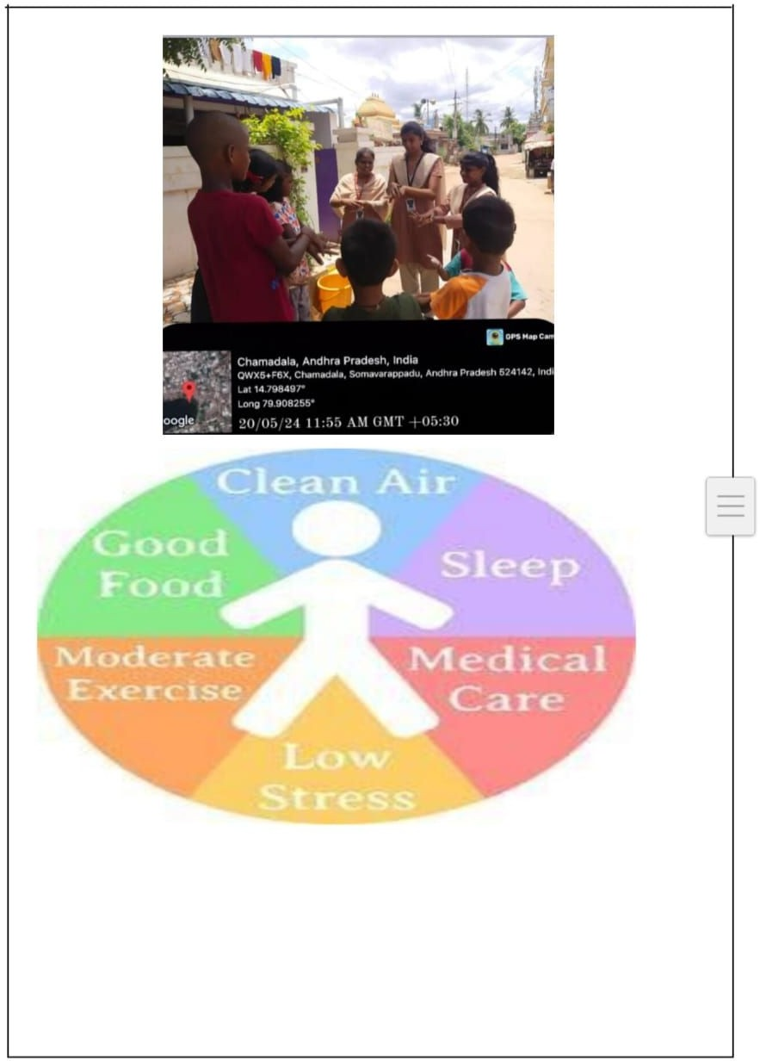

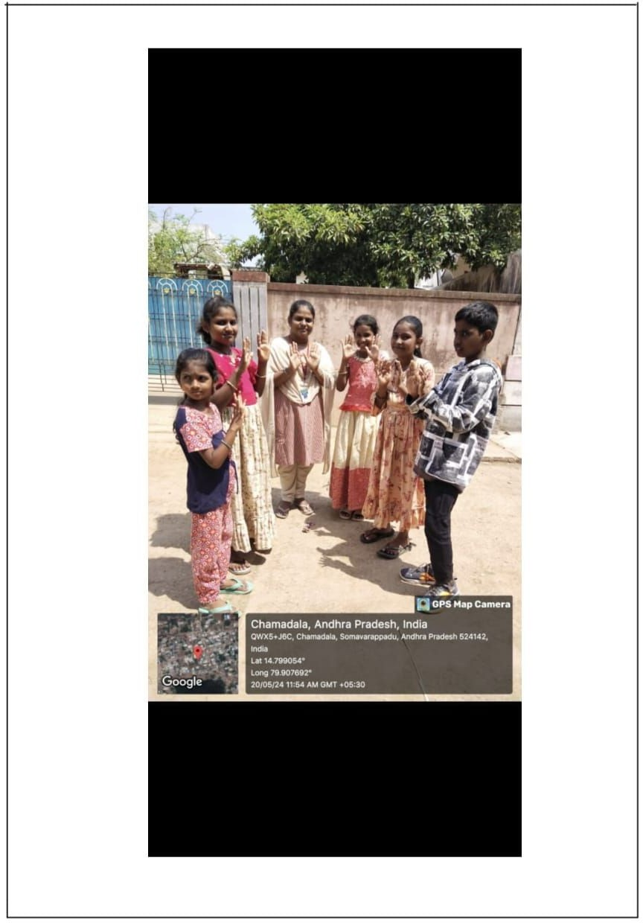

## ACTIVITY LOG FOR THIRD WEEK

|  |  |  |  |
| --- | --- | --- | --- |
| **DAY & DATE** | **BRIEF DESCRIPTION** | **LEARNINGOUTCOME** | **PERSON INCHARGE**  **SIGNATURE** |
| **DAY-1** | On the first day I visited an area which is very polluted and tried to find out how the health is injured due to pollution. | After visiting one area I got to know that how the  health and hygiene is affecting due to the pollution. |  |
| **DAY-2** | On the second day I continued my survey on the polluted area and gathered more information on how  the area is being got polluted and also by whom. | In the survey I got to know that most of the area is  being polluted by the people who are living in that area and I wanted to explain them about the health and hygiene. |  |
| **DAY-3** | On the third day I went to a school in that area and  gathered some children to explain them about the  importance of health and hygiene. | In the school I got good response from the students and they also wanted to follow the healthy  measures to keep their health good. |  |
| **DAY-4** | On the fourth day I started to make an awareness survey on health and hygiene in that area and went to the people and  explained them how to keep their health properly and healthy. | In the survey the people understood the healthy measures through which  they can lead a good health and hygienic society. |  |
| **DAY-5** | On the fifth day I went to that area and collected  information about the unhealthy persons and also children and then I provided them a sanitizer and energy drink. | After receiving the Sanitizer they started to  clean their hands and body to keep their health good. |  |

**WEEK-3 REPORT**

##### (From: 27-05-2024 To: 01-06-2024)

**Objective of the Activity Done:** To spread awareness on Health and Hygiene in the society.

**Day 01:** I visited a area which is very polluted and tried to find out how the health is injured due to pollution. Exposure to air pollution can affect everyone's health. When we breathe in air pollutants, they can enter our bloodstream and contribute to coughing or itchy eyes and cause or worsen many breathing and lung diseases, leading to hospitalizations, cancer, or even premature death.

**Day 02:** I continued my survey on the polluted area and gathered more information on how the area is being got polluted and also by whom.

The impact of air pollution ranges from:

*Increased risk of respiratory illness and cardiovascular problems.

*Increased risk of skin diseases.

*May increase the risk of cancer.

*Global warming.

*Acid rain.

*Ozone depletion.

*Hazards to wildlife.

**Day 03:** I went to a school in that area and gathered some children to explain them about the

importance of health and hygiene. School hygiene or school hygiene education is a healthcare science, a form of the wider school health education. The primary aims of school hygiene education is to

improve behaviour through useful practices connected to personal, water, food, domestic and public hygiene.

**Day 04:** I started to make a awareness survey on health and hygiene in that area and went to the people and explained them how to keep their health properly and healthy.

1. Hygiene is the act of maintaining oneself and keeping one's surroundings clean, especially to avoid illness or disease transmission.
2. The term community hygiene refers to the prevention of disease and the maintenance of a clean environment.
3. The following are the 5 ways through which community hygiene can be maintained: *Garbage and other trash

**Day 05:** I went to that area and collected information about the unhealthy persons and also children and then provided them a sanitizer and energy drink.

* + Creative Ways To Improve Hand Hygiene Compliance at Your... Electronic Message Boards (EMBs) Signage.
  + Make it a part of your rounding.
  + Mention it in every single huddle and meeting. Include checking sanitizer expiration dates on your Environment of Care rounds checklists.

d not be left out in the open.

*Do not defecate in a public place.

*If there are any open drains, they should be appropriately covered.

*Washing clothes or bathing should not pollute drinking water.

*For hygiene, safe and clean water, as well as a pollution-free environment, should be maintained.

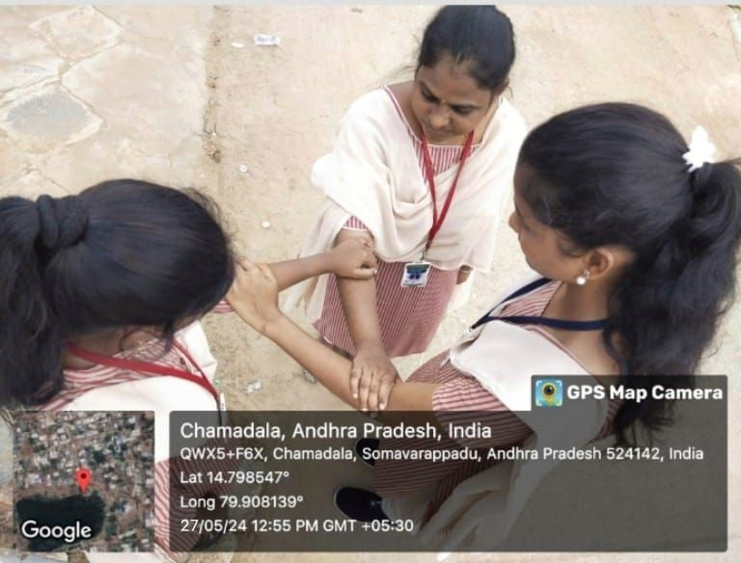

|  |  |  |  |  |
| --- | --- | --- | --- | --- |
| **ACTIVITY LOG FOR FOURTH WEEK** | | | | |
|  | **DAY & DATE** | **BRIEFDESCRIPTION** | **LEARNINGOUTCOME** | **PERSON INCHARGE SIGNATURE** |
| **DAY-1** | On the first day I decided to take an awareness survey on the Toilet Hygiene in our area. | In this survey I got to know that the health of the people is affected due to public urination and other  activities in the public  places. |  |
| **DAY-2** | On the second day I started to gather more  information about public toilets and wanted to  make people to use public toilets instead of spoiling the public place. | In the survey I got to know that many people are not aware about the public  toilets and what is the advantage of using it. |  |
| **DAY-3** | On the third day I started to gather  uneducated people who are not aware of public toilets and explained  them about the  importance of using public toilets and how it is help to keep our health  good. | Many people understand and realise the problems causes due to public  urination and they started to use the public toilets and develop clean and healthy society. |  |
| **DAY-4** | On the fourth day I also wanted to make more awareness program on public toilets and as a part of that I gathered some children and explained  them to use always public toilets. | The children listened the  importance of maintaining good health by using the public toilets and not to destroy the clean environment and society by making it dirty. |  |
| **DAY-5** | On the fifth day I started investing how many public toilets are present in our area and then I explained people to use  them and keep them clean. | After my awareness program people understood about the need of public  toilets and they started to use them and keep them  clean. |  |
|  | | | | |

**Objective of the Activit**

# WEEK4 – REPORT

##### (From: 03-06-2024 To: 08-06-2024)

To spread awareness on Health and Hygiene in the society.

##### Day 01:

1.Close the door. The first of our 10 toilet rules is about the importance of privacy and respect. 2.Wipe from front to back.

1. Avoid pee splash.
2. Clean the toilet seat if necessary. 5.Don't forget to flush.

6.Clean with the toilet brush if necessary. 7.Put the toilet seat down. 8.Wash your hands.

**Day 02:** Toilet Types Explained:

Depending on the circumstances of your public toilets and your preferences, there are quite a few different types of toilets to consider before your last choice of a unit. The process could easily become

overwhelming. 1.Dual-Flush Toilets.

2.Double Cyclone Flush. 3.Pressure Assisted Toilets. 4.Gravity-Flush Toilet.

1. Composting Toilets.
2. Waterless “Dry Sanitation” Toilet. 7.Up flush Toilet. 8. Portable Toilets.

**Day 03:** Toilet Facilities means those devices provided for individual convenience in the sanitary disposal of body wastes and the structures for their installation and maintenance.

Good hygiene is more than just bathing once a day or brushing your teeth. It’s the consistent effort of making sure you keep yourself protected from infections caused by the spread of germs. A perfect example is toilet hygiene. Many think that flushing once you’re done using the toilet and giving your hands a quick rinse is sufficient germ protection, but that’s not necessarily going to keep you safe from infection.

**Day 04:m** Toilets contain a large number of germs and bacteria that can be harmful to you and your health, including a vast number of germs in and around the lid. Toilet hygiene means ensuring your little ones learn how to use the toilet safely, especially making sure they do not touch the lid, for example, and then touch

their face directly after the best way to keep your toilet hygienic is to do a routine deep clean at least once a week. Scrubbing the bowl and wiping down the lid with disinfectant can keep your toilet fresh and clean. A pro tip is to leave the toilet brush soaking in some cleaning product in order to kill off germs. This will ensure that your brush is not spreading germs across your bathroom.

**Day 05:** World Toilet Day is observed on 19th November. The theme for 2018 is “When Nature Calls” which focuses on nature-based sanitation solutions.

Hygiene and sanitation are of an utmost importance when it comes to using toilets. It goes without saying that restrooms harbour numerous bacteria and viruses which puts you at risk of infections. These include

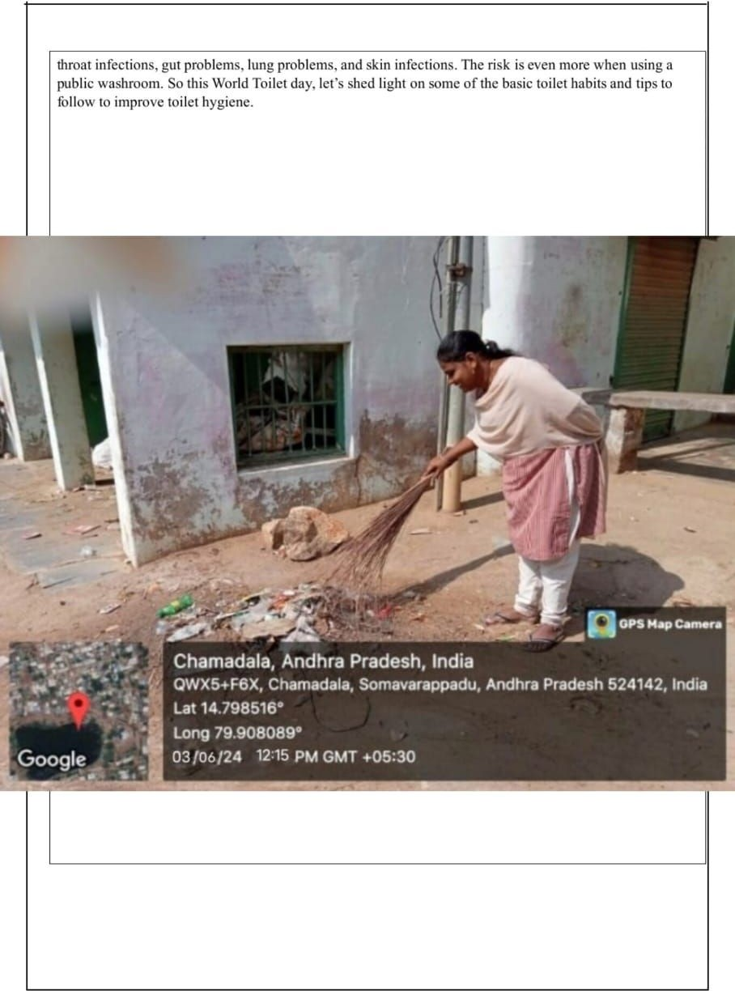

**ACTIVITY LOG FOR FIFTH WEEK**

|  |  |  |  |
| --- | --- | --- | --- |
| **DAY & DATE** | **BRIEFDESCRIPTION** | **LEARNINGOUTCOME** | **PERSON INCHARGE**  **SIGNATURE** |
| **DAY-1** | On the first day I decided to take an awareness program on consumption of Alcohol and  Tobacco in our area. | In this survey I got to know that the health of  the people is affected due to consumption of alcohol and tobacco. |  |
| **DAY-2** | On the second day I started to gather more information about the  people who are addicted to the alcohol. | In the survey I got the  detailed information about alcoholic persons and  there are in major part. |  |
| **DAY-3** | On the third day I started gathering them and explained them  about the importance of health and hygiene and  the dangerous effect due to consumption of  alcohol. | Many people understand and realise the problems causes due to consumption of alcohol and realise the dangerous effect of it. |  |
| **DAY-4** | On the fourth day I continued to make more awareness program on To avoid the use of  alcohol, cigarette and tobacco. | Through the awareness program many people understand the importance of health and hygiene and slowly decrease the use of alcohol and tobacco. |  |
| **DAY-5** | On the fifth day I noted how the alcohol and  cigarette are spreading in the area. | In this survey I got the details that there are more distributors in the area  through which people are consuming more Alcohol. |  |

**WEEK-5 REPORT**

**(From:10-06-2024 To: 15-06-2024)**

|  |
| --- |
| **Objective of the Activity Done:** To avoid consumption of alcohol and improve health and hygiene |
| **Day 1:** Long-Term Health Risks. Over time, excessive alcohol use can lead to the development of chronic diseases and other serious problems including: High blood pressure, heart disease, stroke, liver disease, and digestive problems. Cancer of the breast, mouth, throat, esophagus, voice box, liver, colon, and rectum.  **Day 2:** To reduce the risk of alcohol-related harms, the 2020-2025 Dietary Guidelines for Americans recommends that adults of legal drinking age can choose not to drink, or to drink in moderation by  limiting intake to 2 drinks or less in a day for men or 1 drink or less in a day for women, on days when alcohol is consumed.  **Day 3:** Symptoms of alcohol overdose include mental confusion, difficulty remaining conscious, vomiting, seizures, trouble breathing, slow heart rate, clammy skin, dulled responses (such as no gag reflex, which prevents choking), and extremely low body temperature. Alcohol overdose can lead to permanent brain damage or death.  **Day 4:** Moderate alcohol consumption may provide some health benefits, such as: Reducing your risk of developing and dying of heart disease. Possibly reducing your risk of ischemic stroke (when the arteries to your brain become narrowed or blocked, causing severely reduced blood flow) Possibly reducing your risk of diabetes.  **Day 5:** Risk factors for alcohol use disorder include:   * Steady drinking over time. * Starting at an early age. * Family history. * Depression and other mental health problems. * History of trauma. * Having bariatric surgery. * Social and cultural factors.   Tips to reduce your drinking:   * Count your drinks. * Have alcohol-free days each week. * Swap to low or no alcohol alternatives. * Alternate between alcohol and non-alcoholic drinks. * Know your standard drinks. |

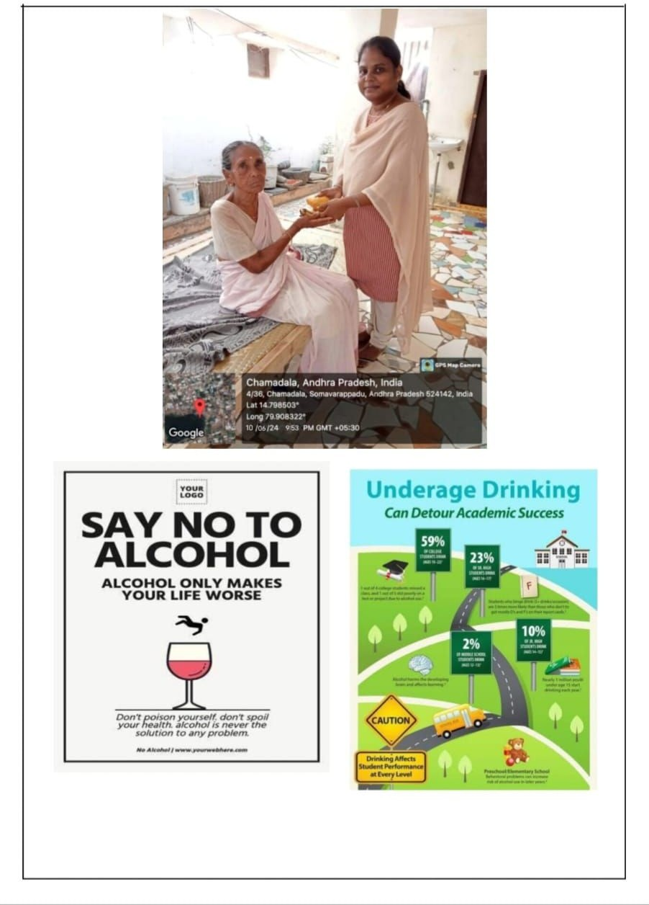

## CHAPTER 5: OUTCOMES DESCRIPTION

The outcomes of a health and hygiene project can have a profound and positive impact on individuals and communities. These outcomes represent the achievements and benefits resulting from the implementation of such initiatives. Some key outcomes of a health and hygiene project include:

* + Improved Health and Well-being: One of the primary outcomes is the improved health of

individuals within the community. Reduced illness rates, lower mortality, and increased overall well-being result from practicing proper health and hygiene.

* + Reduced Disease Transmission: Health and hygiene projects lead to a significant reduction in the transmission of infectious diseases, as community members adopt practices like regular handwashing and vaccination.
  + Cleaner and Safer Environment: Sanitation and waste management improvements create a cleaner and safer community environment, reducing the risk of contamination and the spread of diseases.
  + Access to Clean Water: Projects focused on water quality and access ensure that community

members have a reliable source of clean and safe drinking water, reducing the risk of waterborne diseases.

* + Nutritional Well-being: Initiatives that promote balanced nutrition and educate community

members about healthy eating result in improved nutritional status and a reduced prevalence of malnutrition.

* + Empowered Communities: Health and hygiene projects empower communities with the knowledge and tools to take control of their health, fostering a sense of self-efficacy and responsibility.
  + Preventive Measures: Increased awareness and access to healthcare services lead to the adoption of preventive measures, such as vaccinations and regular check-ups, reducing the burden of disease.
  + Emergency Preparedness: Communities become better prepared to respond to health-related emergencies, including natural disasters and pandemics, minimizing vulnerabilities and risks.
  + Mental and Emotional Well-being: Addressing mental health through awareness campaigns and support services results in reduced stress, anxiety, and depression, contributing to improved overall well-being.
  + Reduced Healthcare Costs: As a result of improved health and preventive measures, healthcare costs decrease, reducing the financial burden on individuals and communities.
  + Economic Benefits: Healthier community members are more productive, leading to economic benefits for both individuals and the community as a whole.
  + Reduced Environmental Impact: Environmental initiatives related to waste management and pollution control contribute to a healthier natural environment and reduced ecological impact.
  + Equality and Equity: Health and hygiene projects promote equality and equity in access to healthcare and sanitation facilities, reducing disparities within the community.
  + Positive Behaviour Change: Health and hygiene projects encourage positive behaviour change, creating a culture of cleanliness, health-consciousness, and disease prevention.

##### CONCLUSION

In conclusion, our health and hygiene community service project has been a significant step towards creating a healthier and more informed community. Through our collective efforts, we've not only raised awareness but also actively contributed to improving the well-being of those in need. Our project

emphasized the importance of personal hygiene, proper nutrition, and overall well-being.

We've witnessed the positive impact of our initiatives, from providing essential hygiene kits to

underprivileged individuals to conducting educational workshops on maintaining a healthy lifestyle. The engagement and feedback from the community have been encouraging, showing that our project has

made a real difference.

As we move forward, it's essential to recognize that promoting health and hygiene is an ongoing process.

We must continue to work together, advocating for good health practices, and extending our support to those who need it most. By doing so, we can ensure that the benefits of this project are long-lasting and that our community remains on the path to improved health and well-being.

Our commitment to this cause is a testament to our dedication to creating a better, healthier, and more

informed community. Let's carry the lessons and experiences from this project with us, inspiring others to join our mission, and together, we can make a lasting impact on the lives of those we serve.

In retrospect, our health and hygiene community service project has been an incredible journey, filled with purpose, passion, and profound impact. As we wrap up this endeavour, it's essential to reflect on the collective efforts and the lasting effects we've had on the community we set out to serve.

From the outset, the primary goal of our project was to address the critical issue of health and hygiene within our community. We recognized that access to proper healthcare, education, and hygiene essentials is not a privilege but a fundamental human right. Our project was born from the belief that we can make a positive change in the lives of those who need it most.

Throughout the project, our dedicated team has worked tirelessly to make this belief a reality. We organized workshops, seminars, and awareness campaigns that not only informed community members but also provided them with practical knowledge and tools to improve their health and hygiene. From

teaching the importance of regular handwashing to discussing the significance of balanced nutrition, we sought to empower individuals to take control of their well-being.

In conclusion, our health and hygiene community service project has been a transformative experience for us as individuals and as a collective force for change. It has reinforced the notion that small actions, when carried out with dedication and compassion, can create significant and lasting improvements in our community.

As we look forward, let's carry the lessons, experiences, and connections from this project with us. Let's inspire others to join our mission and continue the work of promoting health and hygiene. Together, we

can ensure that our community thrives in well-being, knowledge, and compassion, setting an example for others to follow. Our project is not just a moment in time; it's a catalyst for a healthier, happier, and more informed community, and it will continue to shine brightly as a beacon of positive change.

**Report of the mini-project work done in the related subject w.r.t the habitation/TOWN.**

# HEALTH GUARDIANS PROMOTING HYGIENE FOR ALL AND A PATH TO VAITALITY

### ABSTRACT

**TITLE OF THE PROJECT:** A WEB PAGE DESIGNED ON

##### “HEALTH GUARDIANS PROMOTING HYGIENE FOR ALL AND A PATH TO VAITALITY”

**ABSTRACT:**

First, I started a survey on health and hygiene in the selected area and noted how people

are aware to keep their proper health by maintaining a good hygienic society. The survey begins by

emphasizing the importance of health education and awareness. Through targeted campaigns, workshops, and educational materials, the project aims to inform and educate individuals about the significance of adopting healthy habits and practicing good hygiene. By raising awareness, it empowers people to make

informed decisions about their health and take appropriate preventive measures. I divided the task into sub parts and started awareness program on health and hygiene and educated people how to keep their health properly and maintain hygiene society. Another crucial aspect of the project is the promotion of basic hygiene practices. This includes encouraging regular handwashing, proper sanitation, and the use of clean water. Access to clean and safe water is a fundamental right, and the project emphasizes the need to provide adequate water supply and sanitation facilities to all individuals, especially those in underserved communities. In addition to individual-level interventions, the project also focuses on community-wide

initiatives. It encourages the establishment of proper waste management systems, including waste segregation and recycling practices. By promoting environmental cleanliness and minimizing pollution, the project aims to create a healthier and sustainable living environment for all. In conclusion, the Health and Hygiene project is a comprehensive initiative that aims to improve public health and hygiene

practices. By focusing on health education, promoting hygiene practices, enhancing vaccination coverage, addressing environmental cleanliness, and integrating mental health support, this project strives to create healthier and more sustainable communities.

**EXISTING SYSTEM:**

➣I have discussed with the people about their health issues and their problems raising due to improper health and hygiene.

➣I have got to know that the health is also affected due to bad environmental condition.

➣I also noticed that due to improper knowledge many people are leading with bad health conditions.

➣Many people are suffering from diseases due to not having proper sanitation in their area.

➣Now a days the health of the people are effected due to consumption of alcohol and not talking good health.

### Proposed system:

* + - Conducted an awareness activity on health and hygiene and educated the people to improve good health. ✓I started

the awareness program on the needs of the health and hygiene and explained the people about various facts of good health.

* + - I explain how to keep proper health by engaging in regular physical activity, such as exercise or sports, helps improve cardiovascular health, strengthen muscles, and boost mental well-being.
    - Practicing proper oral hygiene, such as brushing teeth twice a day and flossing, promotes dental health and prevents tooth decay and gum diseases.
    - Avoiding excessive consumption of alcohol, tobacco, and drugs plays a significant role in maintaining good health and reducing the risk of various diseases

### Requirements:

* **Hardware:** Laptop, windows11, intel processer, 512GB SSD, 8GB RAM.
* **Software**: vs code, html5,3.

### Architecture:

**HOME**

**CONTACT US**

**ABOUT**

**HEALTH GAURDIANS PROMOTING HYGIENE FOR ALL AND A PATH TO VAITALITY**

INCLUDE THE OVERVIEW OF THE PROJECT.

**MODULES:**

IT CONTAINS THE ALL DETAILED INFORMATION ABOUT THE PROJECT.

HERE YOU

CAN CONTACT US USING ANY SOCIAL- MEDIA.

* The home page gives the user introduction about the theme of the website and the
* reason to which it was built. The home page consists of a navigation bar which has title of
* the project (Health and hygiene). Home page contains the brief intro about health and hygiene and the main part is it contains cards describing various diseases prevalent in ▪ present society and the preventive measures taken against them.

### ACTIVITIES:

* The activities page consists of the list of various activities conducted by our CSP
* team in the locality. We kept an get involved button through which the willing volunteers can
* join our activity and get benefitted and help us to get succeed the information activity such
* as date of commencement, venue, oranizer’s contact number.
* registered in the activity. There is a comments section provided in every activity
* through which the participants can share the thoughts about the activity and ask doubts to fellow participants.

### ABOUT:

* In this you will get the very detailed information about the health and hygiene and the precautions to take to keep our health good.

### CONCLUSION:

This website is created to create awareness and educate people on various aspects related to HEALTH AND HYGIENE. This website helps the people to easily know about the various activities conducted by our team and provides them easy access to all of our activities. This website educates

the people in the way of maintaining healthy life.

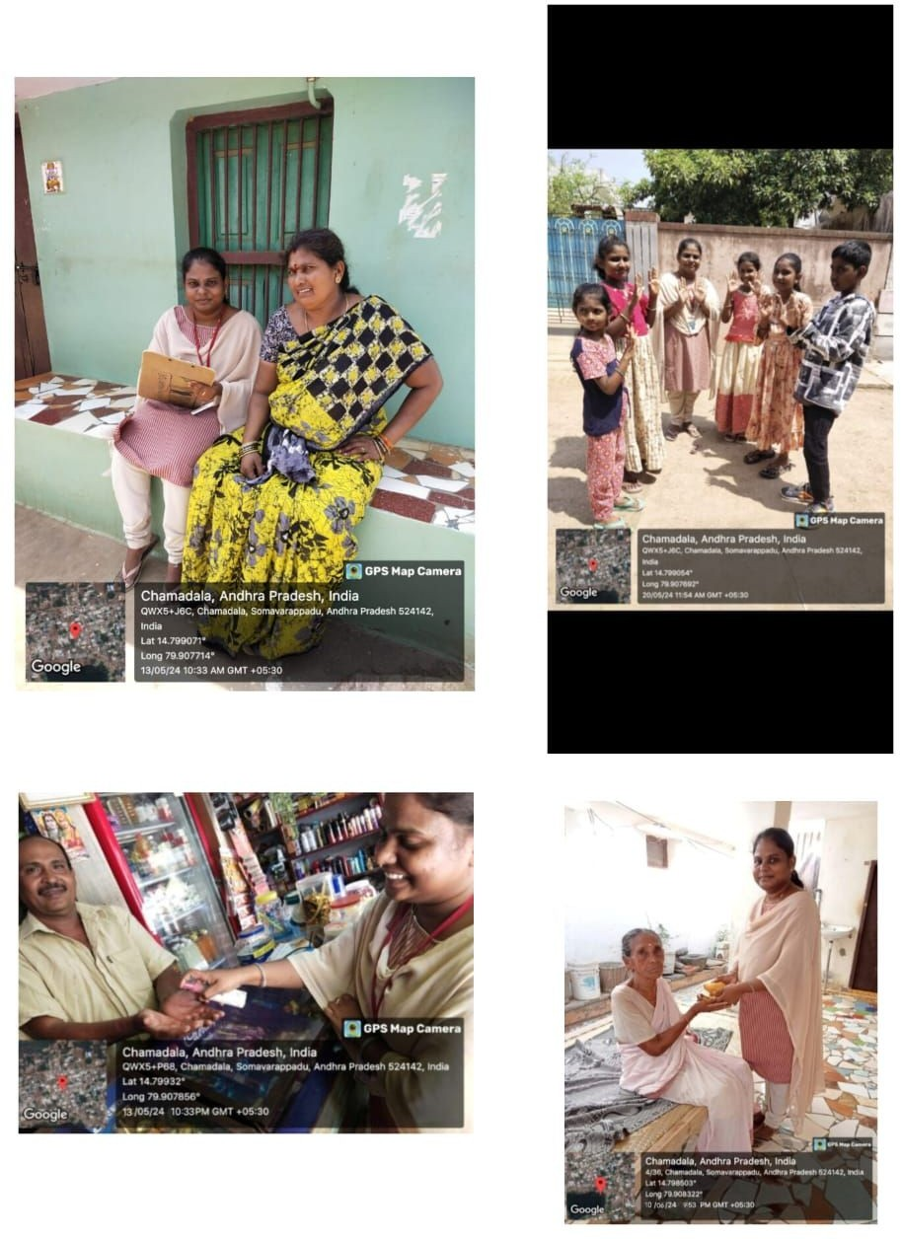

Student Name

##### Student Self-Evaluation for the Community Service Project

:PACHARI SNEHA

Registration No : 22JN1A05B5

Period of CSP. :From: 13-05-2024 To: 06-07-2024

Date of Evaluation :

Name of the Person in-charge Address with mobile number

:Mr. B.RAJASHEKAR REDDY

:chamadala, somavarappadu, Nellore (7780670322)

**Please rate your performance in the following areas:**

**Rating Scale: 1 is lowest and 5 is highest rank**

|  |  |  |  |  |  |
| --- | --- | --- | --- | --- | --- |
| **1) Oral communication** | **1** | **2** | **3** | **4** | **5** |
| **2) Written communication** | **1** | **2** | **3** | **4** | **5** |
| **3) Proactiveness** | **1** | **2** | **3** | **4** | **5** |
| **4) Interaction ability with community** | **1** | **2** | **3** | **4** | **5** |
| **5) Positive Attitude** | **1** | **2** | **3** | **4** | **5** |
| **6) Self-confidence** | **1** | **2** | **3** | **4** | **5** |
| **7) Ability to learn** | **1** | **2** | **3** | **4** | **5** |
| **8) Work Plan and organization** | **1** | **2** | **3** | **4** | **5** |
| **9) Professionalism** | **1** | **2** | **3** | **4** | **5** |
| **10) Creativity** | **1** | **2** | **3** | **4** | **5** |
| **11) Quality of work done** | **1** | **2** | **3** | **4** | **5** |
| **12) Time Management** | **1** | **2** | **3** | **4** | **5** |
| **13) Understanding the Community** | **1** | **2** | **3** | **4** | **5** |
| **14) Achievement of Desired Outcomes** | **1** | **2** | **3** | **4** | **5** |
| **15) OVERALL PERFORMANCE** | **1** | **2** | **3** | **4** | **5** |

**Date: Signature of the Student**

##### Evaluation by the Person in-charge in the Community/Habitation

Student Name

:P.SNEHA

Registration No

: 22JN1A05B5

Period of CSP

Date of Evaluation

: From:13 -05-2024To:06-07-2024

:

Name of the Person in-charge

Address with mobile number

:Mr. B.RAJASHEKAR RESSY

: chamadala, somavarappadu, Nellore (7780670322)

**Please rate the student’s performance in the following areas:**

**Please note that your evaluation shall be done independent of the Student’s self-evaluation Rating Scale: 1 is lowest and 5 is highest rank**

|  |  |  |  |  |  |
| --- | --- | --- | --- | --- | --- |
| **1) Oral communication** | **1** | **2** | **3** | **4** | **5** |
| **2) Written communication** | **1** | **2** | **3** | **4** | **5** |
| **3) Proactiveness** | **1** | **2** | **3** | **4** | **5** |
| **4) Interaction ability with community** | **1** | **2** | **3** | **4** | **5** |
| **5) Positive Attitude** | **1** | **2** | **3** | **4** | **5** |
| **6) Self-confidence** | **1** | **2** | **3** | **4** | **5** |
| **7) Ability to learn** | **1** | **2** | **3** | **4** | **5** |
| **8) Work Plan and organization** | **1** | **2** | **3** | **4** | **5** |
| **9) Professionalism** | **1** | **2** | **3** | **4** | **5** |
| **10) Creativity** | **1** | **2** | **3** | **4** | **5** |
| **11) Quality of work done** | **1** | **2** | **3** | **4** | **5** |
| **12) Time Management** | **1** | **2** | **3** | **4** | **5** |
| **13) Understanding the Community** | **1** | **2** | **3** | **4** | **5** |
| **14) Achievement of Desired Outcomes** | **1** | **2** | **3** | **4** | **5** |
| **15) OVERALL PERFORMANCE** | **1** | **2** | **3** | **4** | **5** |

**Date: Signature of the Supervisor**